**Chromosomes and Meiosis Review sheet**

1. Draw an unduplicated chromosome.

2. Draw a duplicated chromosome.

3. Put the following steps to the cell cycle in the correct order:

6- Cytokinesis 2- prophase 4- anaphase 5- telophase 1- Interphase 3 - metaphase

4. From the list above, during which phase does DNA duplicate or make a copy of itself? ____Interphase______________

5. At the beginning of mitosis are chromosomes duplicated or unduplicated? __Duplicated___________________________ (Hint, the goal of mitosis is to split a cell in two. At the beginning of that process (prophase), you want your one cell to have double the DNA so that at the end the two new cells each have one copy of the DNA)

6. Meiosis is a process to form what kind of cells? _____Haploid____________________

7. How many chromosomes are in a normal human body cell? ____46______________

8. How many SETS of chromosomes are in a normal human body cell? ____23_______________ (Hint: We can represent this number of sets by saying that the cell is diploid)

9. How many chromosomes are in a human egg cell or sperm cell? ____23________________

10. How many SETS of chromosomes are in a normal human sex cell? _____23_________________ (Hint: We can represent this number of sets by saying that the cell is haploid)

11. What are homologous chromosomes? ___2 copies of each autosome________________________________________________

12. What is the result of meiosis?

a. 2 haploid daughter cells b. 4 haploid daughter cells  
c. 2 diploid daughter cells d. 4 diploid daughter cells

13. How many cell divisions are in meiosis? _____2___________________

14. In prophase 1 of meiosis, homologous chromosomes pair up and a process called ___crossing over__________________________ occurs, which causes a piece of one chromosome to break off and switch places with a piece of another chromosome.

15. Sex cells are haploid/diploid (circle one). Explain why.

16. Draw a Venn diagram on mitosis vs meiosis.

17. Cancer is a disorder in which some cells have lost the ability to control their _cell cycle__________.

18. True or False - Down Syndrome is an example of nondisjunction, where chromatids fail to separate properly during Meiosis.

19. What do cyclins do? Internal regulators that regulate growth and development

20. Where does cell division occur in the cell cycle? Nucleus

21. A body cell with 36 chromosomes undergoes mitosis. How many chromosomes will each daughter cell have? 36

22. In meiosis, homologous chromosomes separate during what phase? Anaphase 1

23. How could you tell if a patient had Down Syndrome by looking at their karyotype? 3 chromosomes on the 21st pair

24. What is the end result of meiosis? 4 genetically different cells Mitosis? 2 genetically different cells

25. What is the male gamete? Sperm Female gamete? Egg

26. Gametes are produced by what process? Meiosis

27. Why is crossing over important? Unique genetic variability

28. What is the role of spindle fibers during mitosis? Helps guide and separate chromosomes

29. What happens during cytokinesis? Division of cells cytoplasm; cleavage furrow; cell begins to split

Homologous chromosomes

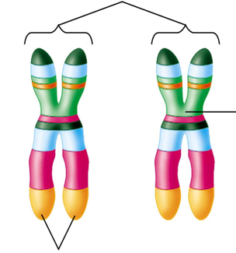30. Label the following

centromere

Sister chromatids